DSA0179-OBJECT ORIENTED PROGRAMMING WITH C++

DAY-3 PROGRAMS

K.Sree Durga Geethika

192111472,CSE.

1. Write a program to print the area and perimeter of a triangle having sides of 3,4 and 5 units by creating a class named ‘Triangle’ With a function to print the area and perimeter.

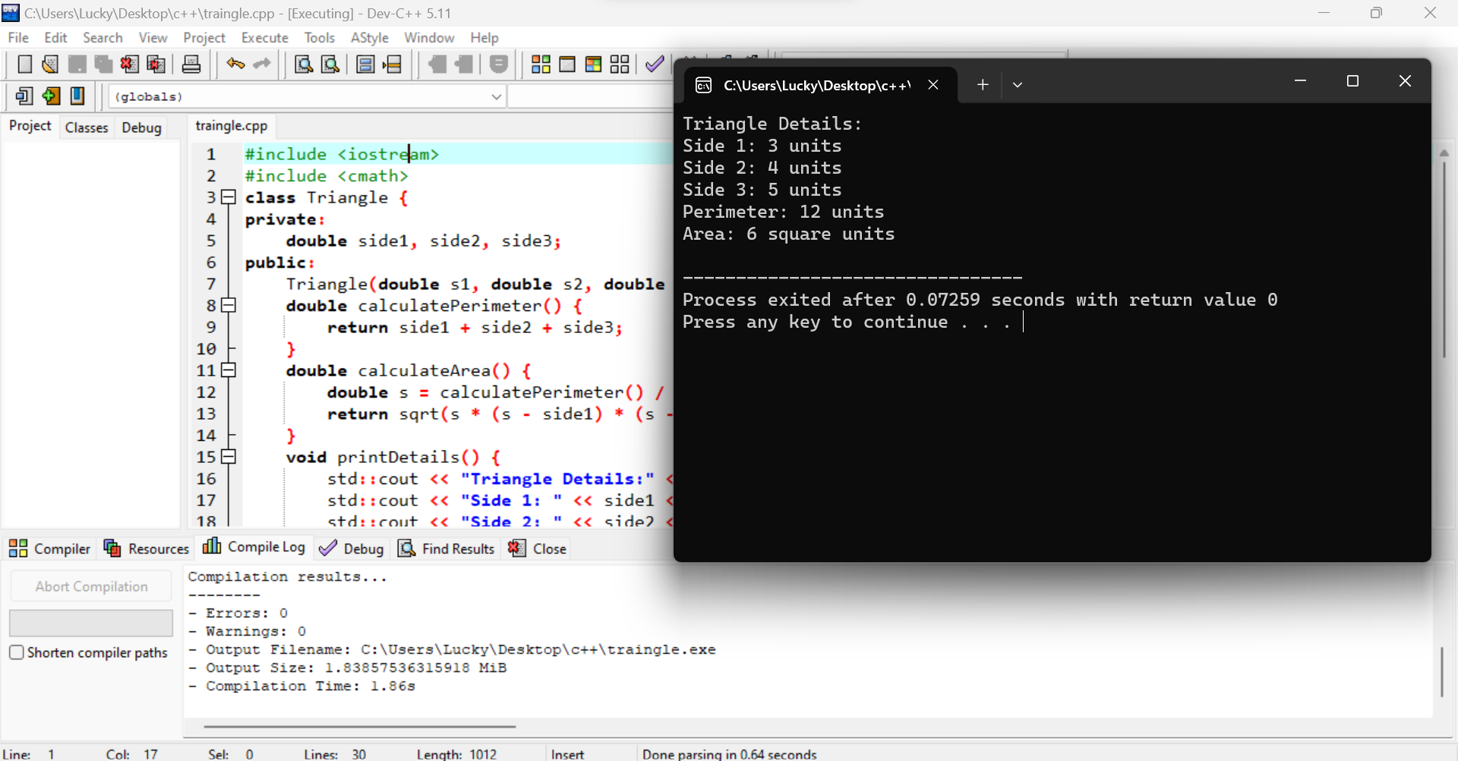

1. Write a program to find the sum of the series  
   1!/1+2!/2+3!/3+4!/4+5!/5

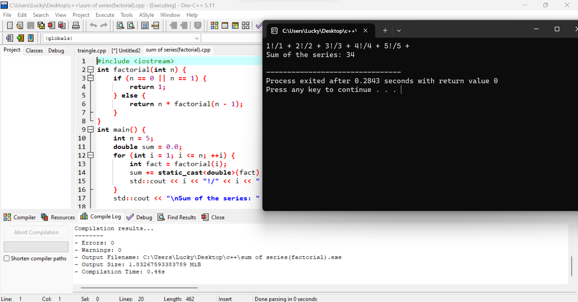

1. Write a c ++ program to find smallest element missing in a sorted natural numbers  
   array?

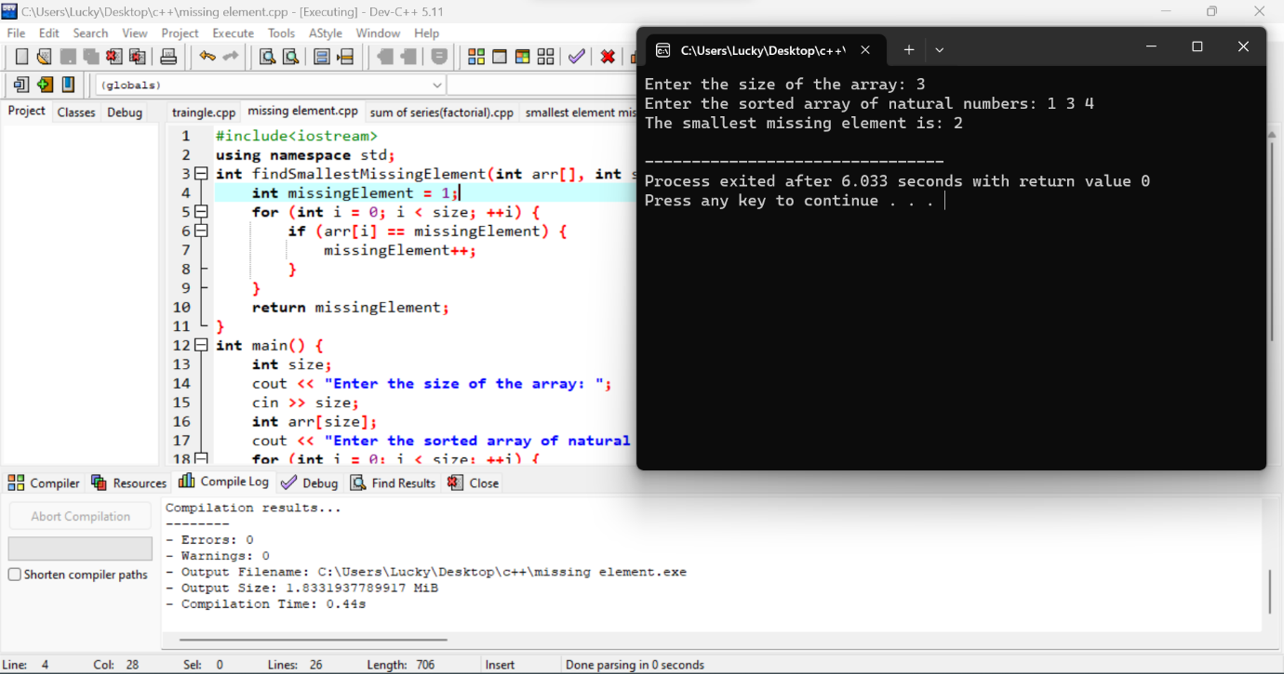

1. Write a program to order the array of elements  
   in non-Decreasing order.

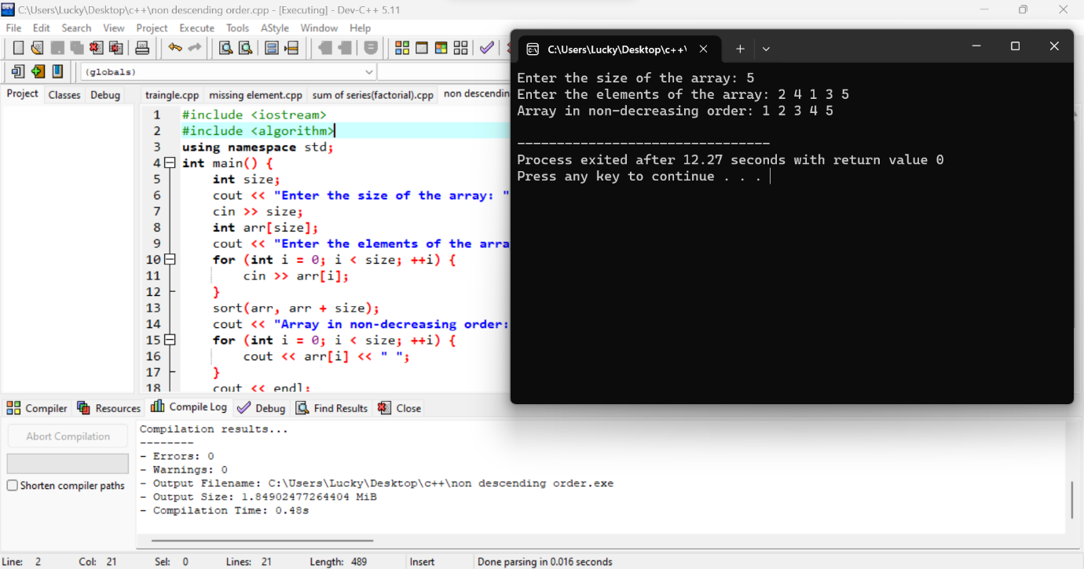

1. Write a program in C++ to store n elements in an array, sort  
   and print the elements using pointer.

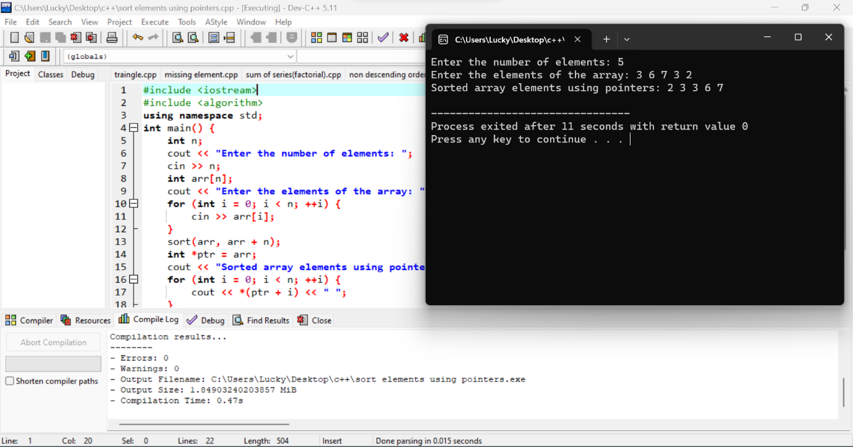

1. Write a C++ program to find whether the person is eligible for vote or not.  And if that particular person is not eligible, then print how many years are left to be eligible.

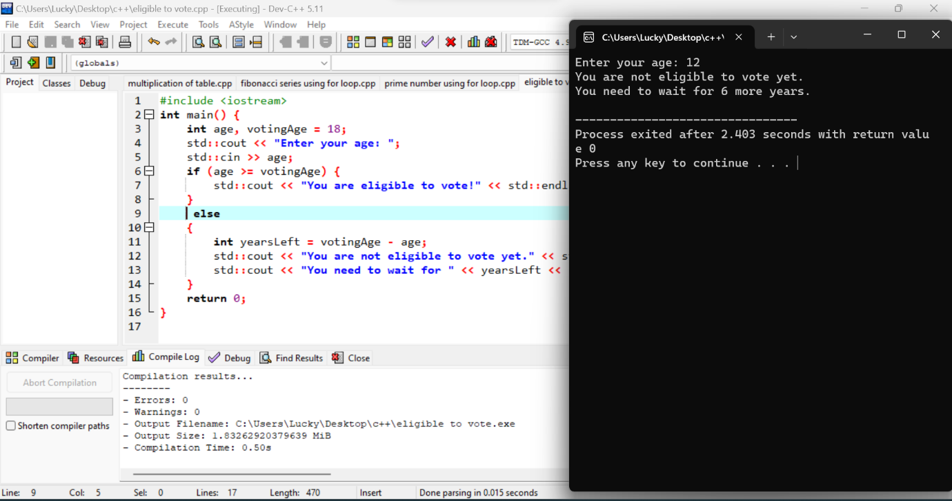

1. Celsius and farenheit:

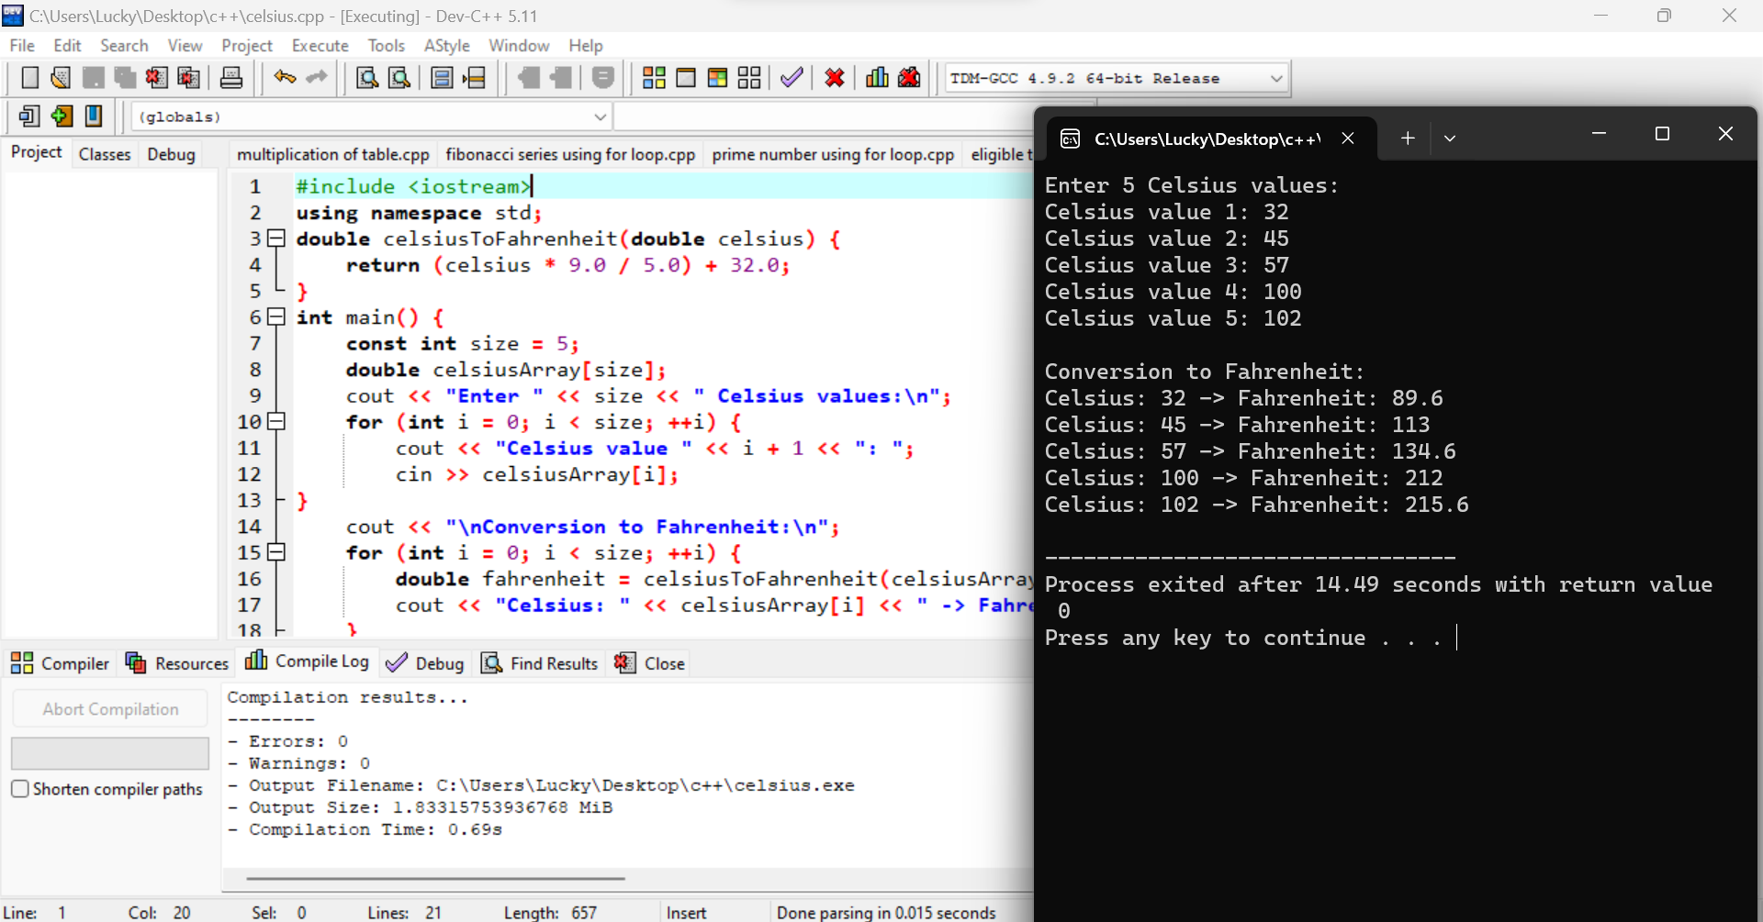

1. Class degree

